Phase 1 Project

1) Create Project Phase1 Project
2) Add all the driver files for chrome and FF
3) Add all the selenium jar files
4) Create the packager
5) Create AmazonSearch.java class
6) open amazon.in website
7) Search iphone12 and get all the product names and their price on console

Java program with the console output
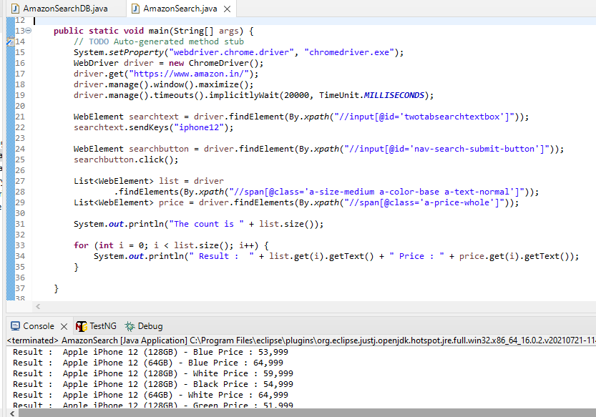

Amazon Webpage
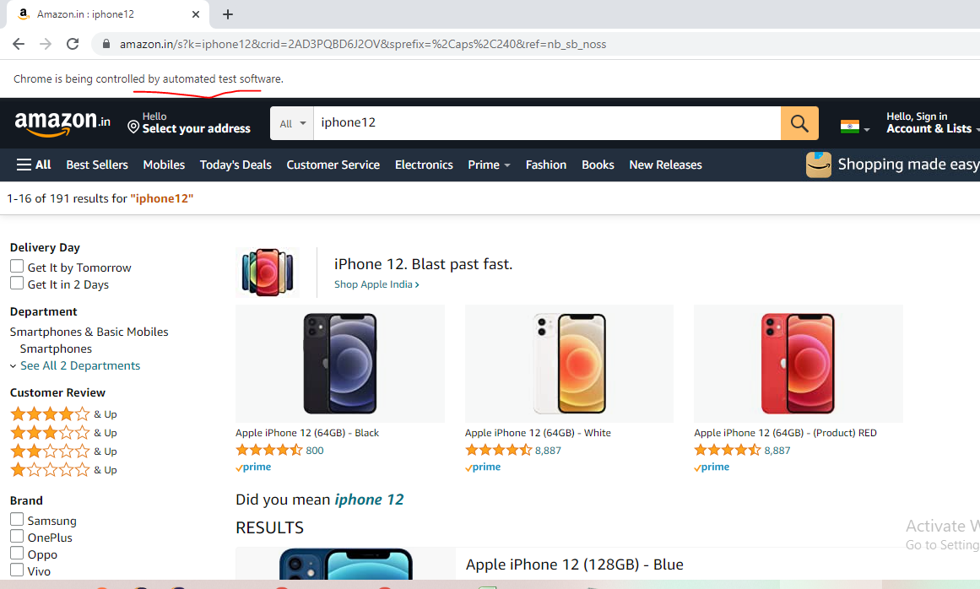

Program to display the list of products in both DB and Amazon website
DB Snapshot
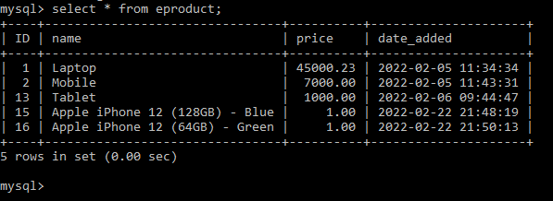

Java Program and console output
